**How to Clone a Cat**

1. Start a new Scratch project.
2. Create 10 additional cats using this code. Note: the original cat is not displayed

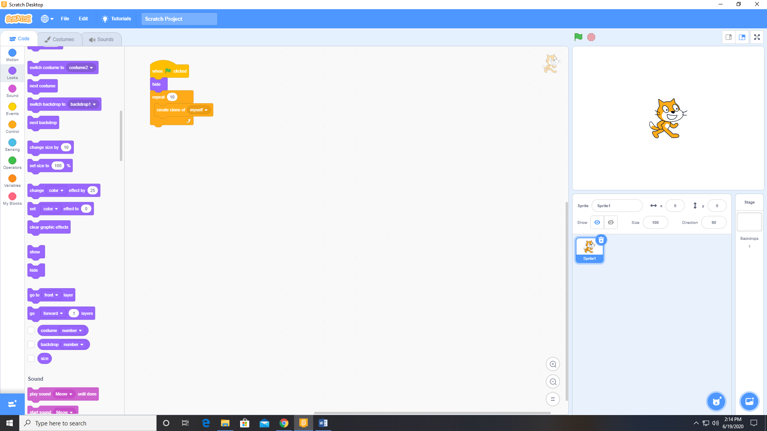

1. As each cat is created (cloned) , we will place the cat at a random location using this code.

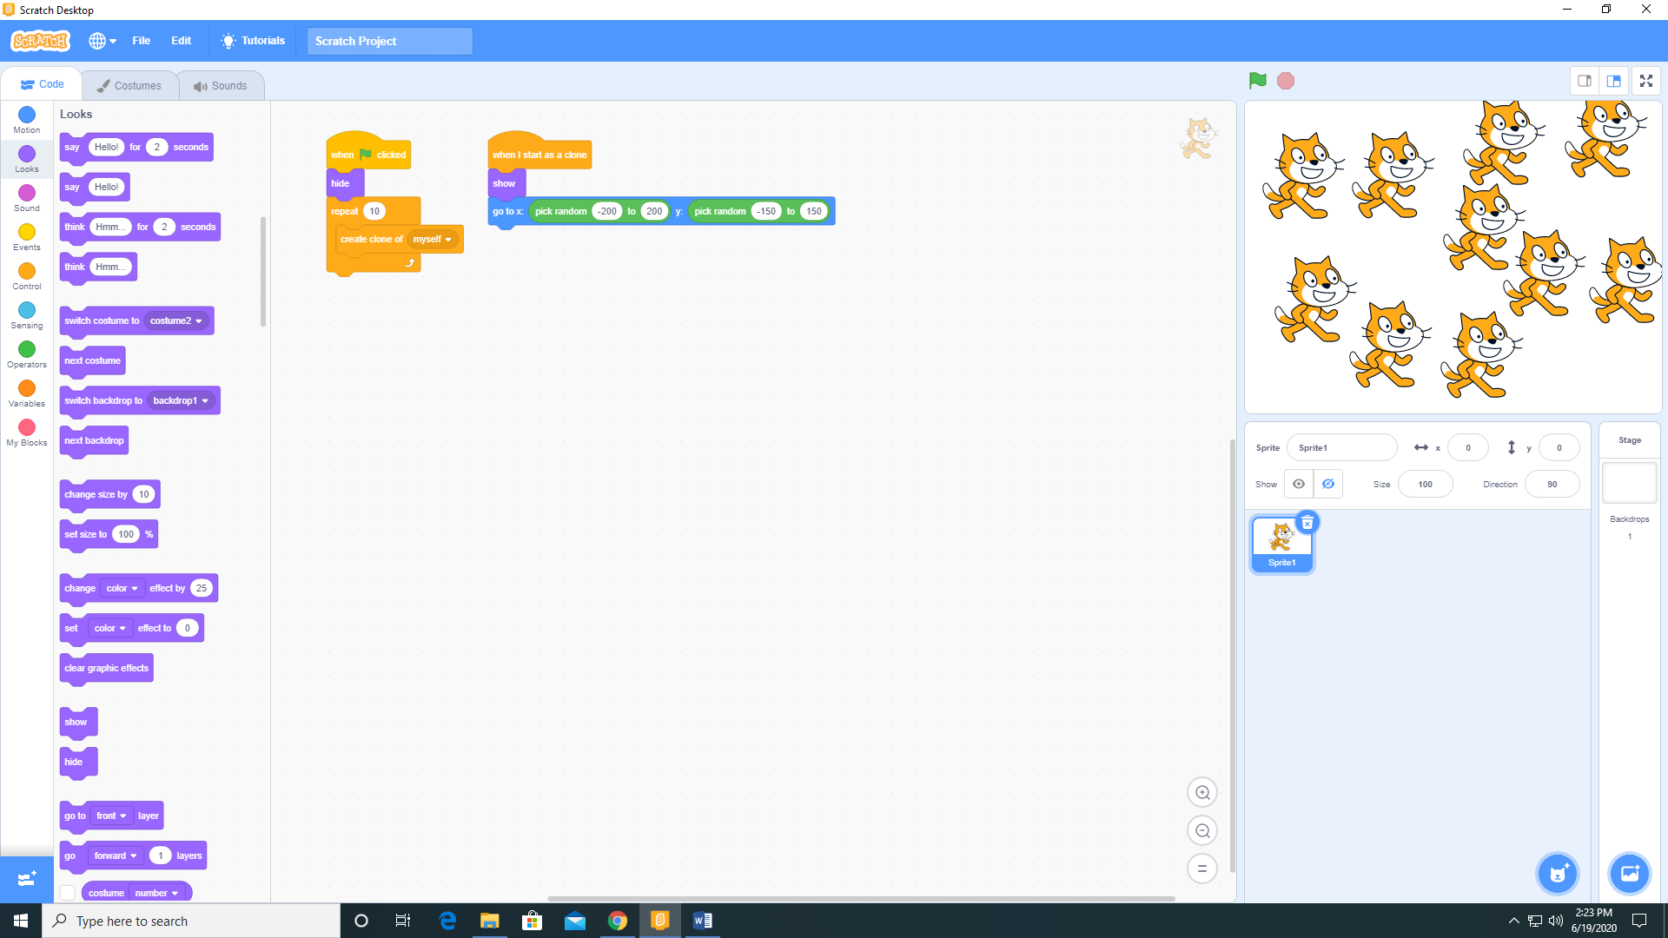

The result is 10 cats

